NEW New Dis-Eur-France-Le Grand Pressigny-Borer-Mousterian-60.000 BP  
 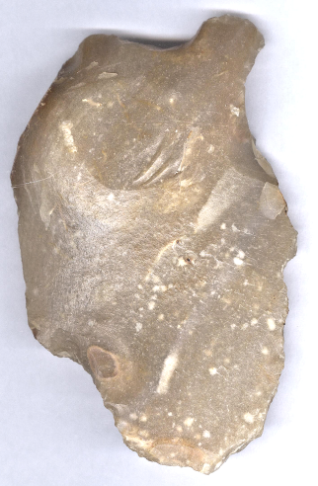 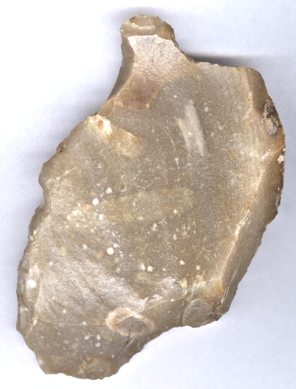

Fig. 1, 2 Le Grand Pressigny-Borer-Mousterian-60.000 BP.

**Formal Label:** Le Grand Pressigny-Borer-Mousterian-60.000 BP

**Accession Number:**

**Display Description:** This Mousterian borer was probably manufactured for making fasteners for hide clothing and was flaked from Le Grand Pressigny flint by *Homo Neanderthalensis.* It was found at a hunting camp in the local area where it had been discarded. Neanderthals followed game where ever it took them with little forward thinking.

**LC Classification:** GN776.22.F7

**Date or Time Horizon:** 60.000 BP.

**Geographical Area:** Le Grand Pressigny.

**Map, GPS: 46.90973, 0.91548**

 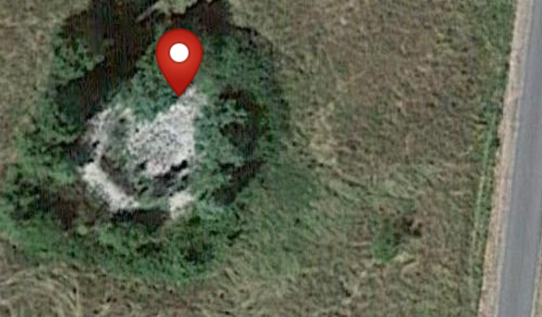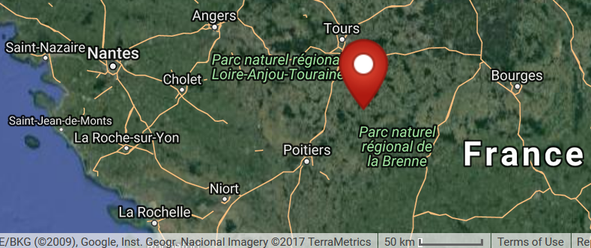

Figs 5-7: Maps of Le Grand Pressigny flint mines in the vicinity of Le Petit Pressigny. source Google.

**Cultural Affiliation:** Mousterian, *Homo Neanderthalensis.*

**Medium:** Le Grand Pressigny Flint.

**Dimensions: H 3.36 in (85.38 mm), T1 1.9 in 49.1 mm, T2 1.30 in. (32.92 mm)  
Weight:**

**Provenance: from an** old Belgian collection.

**Condition:** original.

**Cultural Affiliation:** Homo Neanderthalensis.

**Dimensions:   
Weight:**

**Provenance: from an** old Belgian collection.

**Discussion:** The Mousterian industry appeared around 200,000 BP and persisted until about 40,000 BP, in much the same areas of Europe, the Near East and Africa where Acheulean tools appear. In Europe these tools are most closely associated with *Homo neanderthalensis*, but elsewhere they were made by both *Homo neanderthalensi*s and early *Homo sapiens sapiens*. This type of tool is associated with *Homo neaderthalensis* based on its taphonomy in Neanderthal hunting camps.

**References:**

Green, R.E., et al. 2008. “A complete Neanderthal mitochondrial genome sequence determined by high-throughput sequencing,” *Cell*: 134: 416–426.

Harvati, K., S. R. Frost and K. P. McNulty. 2004. ["Neanderthal taxonomy reconsidered: implications of 3D primate models of intra- and interspecific differences,"](https://www.ncbi.nlm.nih.gov/pmc/articles/PMC337021) *Proceedings of the National Academy of Sciences,***101**: 1147–52*.*

Hublin, J. J. 2009. "The origin of Neanderthals," *Proceedings of the National Academy of Sciences*, **106** (38): 16022–7.

Louboutin, C. 2011. Archeology of the Touraine. Paris: Éditions La Simarre